Behavior Intervention Plan
Individual
- GG is a 9 year old boy who is in the 4th grade at Saxvik Elementary.
- The setting that this behavior intervention plan is to take place at is in the home or at the Anne Carlsen Center with DSP’s or AI’s.
Target Behavior
Outburst is the target behavior for GG. Outbursts may look like …
- calling people names or using foul language such as, “stupid or natzi”
- Or his tone of voice increases
- or makes animal noises
- or will argue with staff by questioning what they say, “asking why”
- or can become aggressive by pretending he is going to pinch staff

Function of Behavior
- Attention and Tangible
Outbursts can appear when he becomes frustrated, told that he is being disrespectful or given instructions he might not like. The outbursts happen more frequently if he hasn’t had his medication for his Autism.
- Through working with this student, the Motivation Assessment Scale (MAS) and the Functional Analysis Screening Tool (FAST) completed by the classroom teacher, special education case manager and another specialist, GG hypothetically engages in outbursting in the classroom to seek attention from adults or obtain a preferred item due to context. Based on observation, maintaining consequences are adult attention and obtaining preferred items or activities.
Baseline of Target Behavior
The baseline behavior frequency over 5 days is 28.6 times per day.

Replacement Behavior

- In order to gain attention by adults or peers or obtain his preferred item, GG will ask the adults/peers to focus attention to him instead of outbursting with a higher tone of voice or making animal noises to gain attention.
Intervention Plan
- In order to support the growth of the replacement behavior with GG, there is going to have to be communication between home, school and teacher-teacher in order to have success.
  - This can look like a communication journal after any outbursts occur, the reasoning why it occurred and what happened afterwards. Or if there were any questions.
  - A phone call once a week from teacher to home in order to discuss the behavior and after the behavior plan has been implemented after a month and behavior is slowly declining, phone calls can happen once or twice a month.
- When GG is starting to outburst, first say “no thank you” and express what you want him to do.
- DRL intervention would be appropriate for him.
- Start by using 1:1 ratio reinforcement when GG is asked to do a task or told something and the outburst does not occur.
  - The reinforcement can also be more time to be the teacher’s helper.
- When GG doesn’t have an outburst when the teacher or individual asks GG to do something he may not like, praise him and say he can get 1 added minute to his sensory breaks or minutes to work with the teacher on a project.
- GG will choose 3 or 4 activities he likes to do when at school if there is a free time.
  - Every time the replacement behavior occurs over the target behavior, GG gets a point on his visual point system (see attached). By the end of the day, if he gets 7 points, GG can choose an activity to do for the last part of the day.
    - See point system attached
- In the morning, he will choose which activity he is working for that day. Once the minutes add up to a certain criteria (depends what team find appropriate) GG gets participate in that activity.
Consequence for “Extreme” Behavior
- Refer to Safety Plan if applicable

Data Collection Method
- Data collection of this Behavioral Intervention Plan will need to be collected by the frequency the outbursts happen.
  - The data will be recorded through observations and point systems.
  - When recording, make sure the information that’s recorded includes
    - Time of outburst
    - What GG was asked or told to trigger the outburst
- The people who will record the data are the people who have him in class or are in charge of him, ex: aide, special education teacher, gen. Ed. teacher, specials teacher

Graph of Data

Baseline Intervention
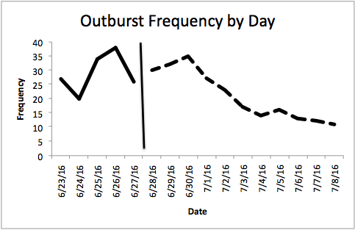
Recommendations for further Plan Adjustment
If the Behavioral Intervention Plan were to not show improvement of GG’s outbursts…
- Change the reinforcement piece to something else he likes or something for him to work towards out of school and have his reward with the DSP at Anne Carlsen Center
- Promote self-monitoring
- The reinforcement rate may need to be increased or decreased
Date for Plan Review
The plan will start being implemented on June 23rd, 2016. In roughly 6-10 weeks when plan has been implemented for that amount of time, the team will be sent out a prior notice email to come together and review the data collected and discuss the Behavioral Intervention Plan.

