Philosophy of Classroom Management
University of Mary
Mikaela Long

Classroom Management
Dr. Lamb

Philosophy of Classroom Management
I believe that having a proper and well-prepared classroom management plan installed in the classroom is very beneficial and essential to having an organized and productive school year. I am committed to making my classroom a safe and comfortable learning environment for my students. I want my students to be challenged and engaged through the curriculum being taught to them. However, I hope that they are challenged enough where they want to keep learning and not give up.
I feel that as a teacher, it is my responsibility to not only teach the curriculum but also acquire the curriculum to all of my students learning abilities. As a general or special education teacher, we will have a various learning needs and abilities and teachers need to come up with a creative way to hit all of those benchmarks.
I believe I need to have a patient and calm attitude towards my students and while working with them. If a teacher is always yelling or nagging, students won’t feel comfortable or safe in the classroom environment. However, I don’t want to be too calm or lose respect with my students because I believe that classroom management can be ruined if the students feel as if they don’t have a learning environment with control or structure.
I am determined to stress to my students that they are in charge of their learning. They have the power to be anything they want to be if they believe in themselves, because I do. I also want to lay down the expectations right away so they know that I am serious about teaching and that they are in control of what they can learn. Above all, I want my students to know that I am there for them and I care for their best interest while teaching them what they need to know.
Classroom Organization/Structure
If I were to design my classroom desks, pods and reading rug any way I would want, I think this would be the design of my classroom.

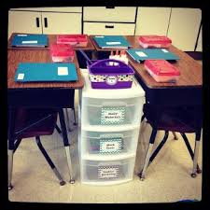

http://iris.peabody.vanderbilt.edu
I really like the idea of having a tote in between the desks because it helps with organization of students and time management. I have seen in a classroom where students need to get up and go grab math materials or building blocks. It causes a lot of unnecessary time for students to be up and walking around. If the storage totes were right by their desks, students could grab what they needed right away and get back to work. The students could also use this as a designed spot to place or pick up their permission forms, absence excuse, etc. (Marzano & Pickering, 2003, 89).
If I were to use this desk layout, I would want to arrange the desks in order for the students to face the smart board, not my desk. Because I wouldn’t be teaching from my desk a whole lot, the arrangement of the desks is critical to student learning.
I also think that cooperative learning is an important skill for students to have on a daily basis. This desk cluster layout would be a good way for students to have easy discussion and collaboration with one another. Yes, this type of layout can lead to the misbehavior of students but minimizing distractions and talking could be handled by separating each desk to give personal space to students. But in the beginning of the year, self-control needs to be discussed with the students making sure they know it is their responsibility to be in control of their learning.
Classroom Procedures
Consistency plays a huge role in the classroom. Without consistency, usually the entire class and the teacher gets confused and has a hard time focusing and being productive. In my room, I want to the have the class schedule and time written on the board. Not only does it help me stay on top of things, my students then know what is going to happen next. I would also have the students write the schedule down in their planner to teach them organization and planning skills.
Morning Meetings:
Every morning, after the morning announcements, I would like to have the students and I to have morning meeting. This would be the time where I would teach them different ways to greet each other, read the morning message, announce the schedule and reminders and have them start their day. Morning Meetings are a good way to create togetherness and community throughout the classroom environment.
Getting Students Attention:
There are so many ways to get the attention of your students. Each class is different and every year you might have to try a new method of getting the students attention. What I want to try in my classroom would be the counting down from 5 to 1 technique, using a musical object and also using the call back method. What I would use would be the teacher saying, “Hey Hey” and the students reply with “Hey What.”
Every Classroom, Everyday
As a teacher, it is our job to be the leader and role model in the classroom to all the students. If we have our own Core Beliefs in our classroom, it can provide us when teaching and working with students for the right reasons, even if the days our difficult. It’s important for not only our students to see their students as a positive and influential leader, but for ourselves to reflect on being a positive and influential leader in the classroom, (Fay-Funk, 1995, pg. 52.)
I think a way that our students can start to see how their teacher is a trustworthy person is by starting right away on the first day of school. Not only greeting them at the door on the first day, but everyday is critical. Giving the students a bag filled with items that have special meanings is another way students can feel safe and feel they can count on one another.
In our Classroom Management book, there was a greeting that uses this strategy for the students feeling welcome in the classroom. These Items in the bag are to be discussed during the first day of school (Marzano & Pickering, 2003, pg. 57). Examples of the items and the sentimental meanings behind them include:
- Cotton Ball- reminds the students that the room is full of kind words and warm feelings.
- Eraser- everyone makes mistakes and that is okay
- Toothpick- reminds you to pick out the good qualities in your classmates and yourself.
- The gold thread reminds you that friendship ties our hearts together
- Life Saver- reminds you that you can come to me if you need someone to talk to.
I think this would be an outstanding method to reach out to the students on the first day and remind them that as a class, they are special together and independently.
Dear Parents and Students,

My name is Miss Long and I am going to be your teacher this year! There are lots of new things to learn and new friends to be made. I hope you had a fabulous summer and I can’t wait to hear all about it.
I hope to meet you at our Open House on Tuesday August 12th, 2015 at 6:00 PM. You can bring your school supplies and backpack with you then or you can bring them with you on the first day of school.
For the first day, make sure you have
- Crayola Crayons & Markers
- 3 Two pocket folders
- 3 college ruled notebooks
- Six #2 Pencils
- Box of Kleenex
- Ruler
- Protractor
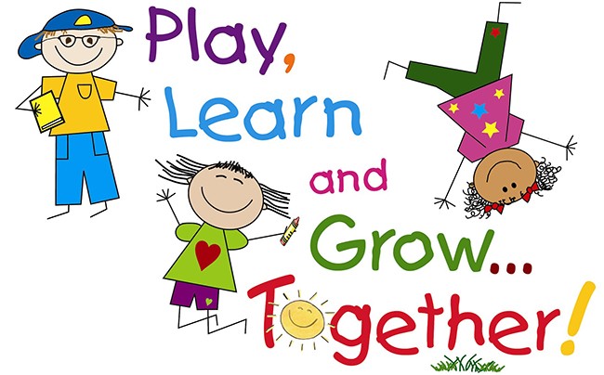
I hope you are excited as I am for school to start. School starts on August 20th at 8:20 am. Our room is number 204 and I’ll be standing outside the door welcoming you to start a new year!
~Miss Long
References
Marzano, R. J. & Pickering, D. J. (2003). Classroom Management that Works: Research –based strategies for every teacher. ASCD Press: Alexandria, VA
Fay, J. & Funk, D. (1995). Teaching with Love & Logic: Taking control of the classroom. Love & Logic Press Inc: Golden, CO.
Freedman, Allan. "Sample Classroom Management Plan." Sample Classroom Management Plan. N.p., n.d. Web. 13 Dec. 2015.
"The Real Teachr: Classroom Seating Arrangement." The Real Teachr: Classroom Seating Arrangement. N.p., 19 June 2012. Web. 13 Dec. 2015.

